Clear Water Jet 5-K

**SKU Code: CWJ5K**

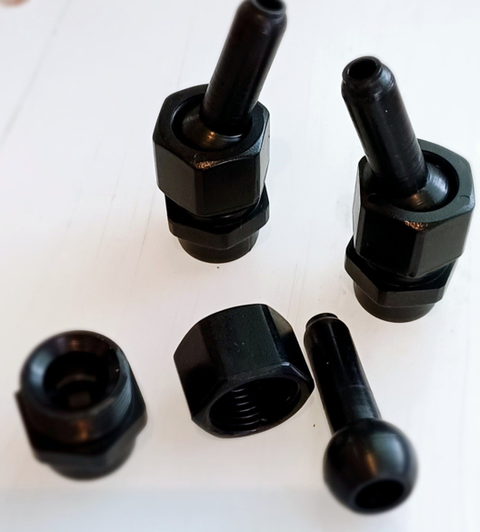

**Key Features**

* Multi-stage water pattern
* Display with minimum distortion
* Designed for precision use with spray ring

**Characteristic**

* Material of construction if plastic with swivels of adjustable connection
* Water level independent nozzles
* Adjustable by 15* from the centre line in every direction

